06 January 2026
NAME: KHADIJA ABUBAKAR | Age: 17y | Sex: F | Ref No:00010
Clinical Details: OBS
REAL TIME PELVIC ULTRASONOGRAPHY EXAM: REVEALED:

URINARY BLADDER: Distended with urine with normal mucosal thickness. No gross masses or stone seen.

UTERUS: The uterus is gravid and shows single live embryo in the uterine cavity with cardiac activity. The cervical Os is closed. Right and Left adnexa are free.

CUL-DE-SAC: No sonographic abnormalities detected in anterior and posterior cul-de-sac.

Biometry:
- CRL = 74 mm
- EGA = 13 weeks 02 day(s)
- EDD = 14/07/2026 (±2weeks)

CONCLUSION: Single live embryo at about 13 weeks 02 day(s) GA.
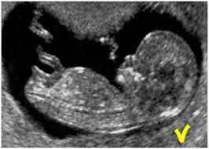

Ultrasound Specialist.

